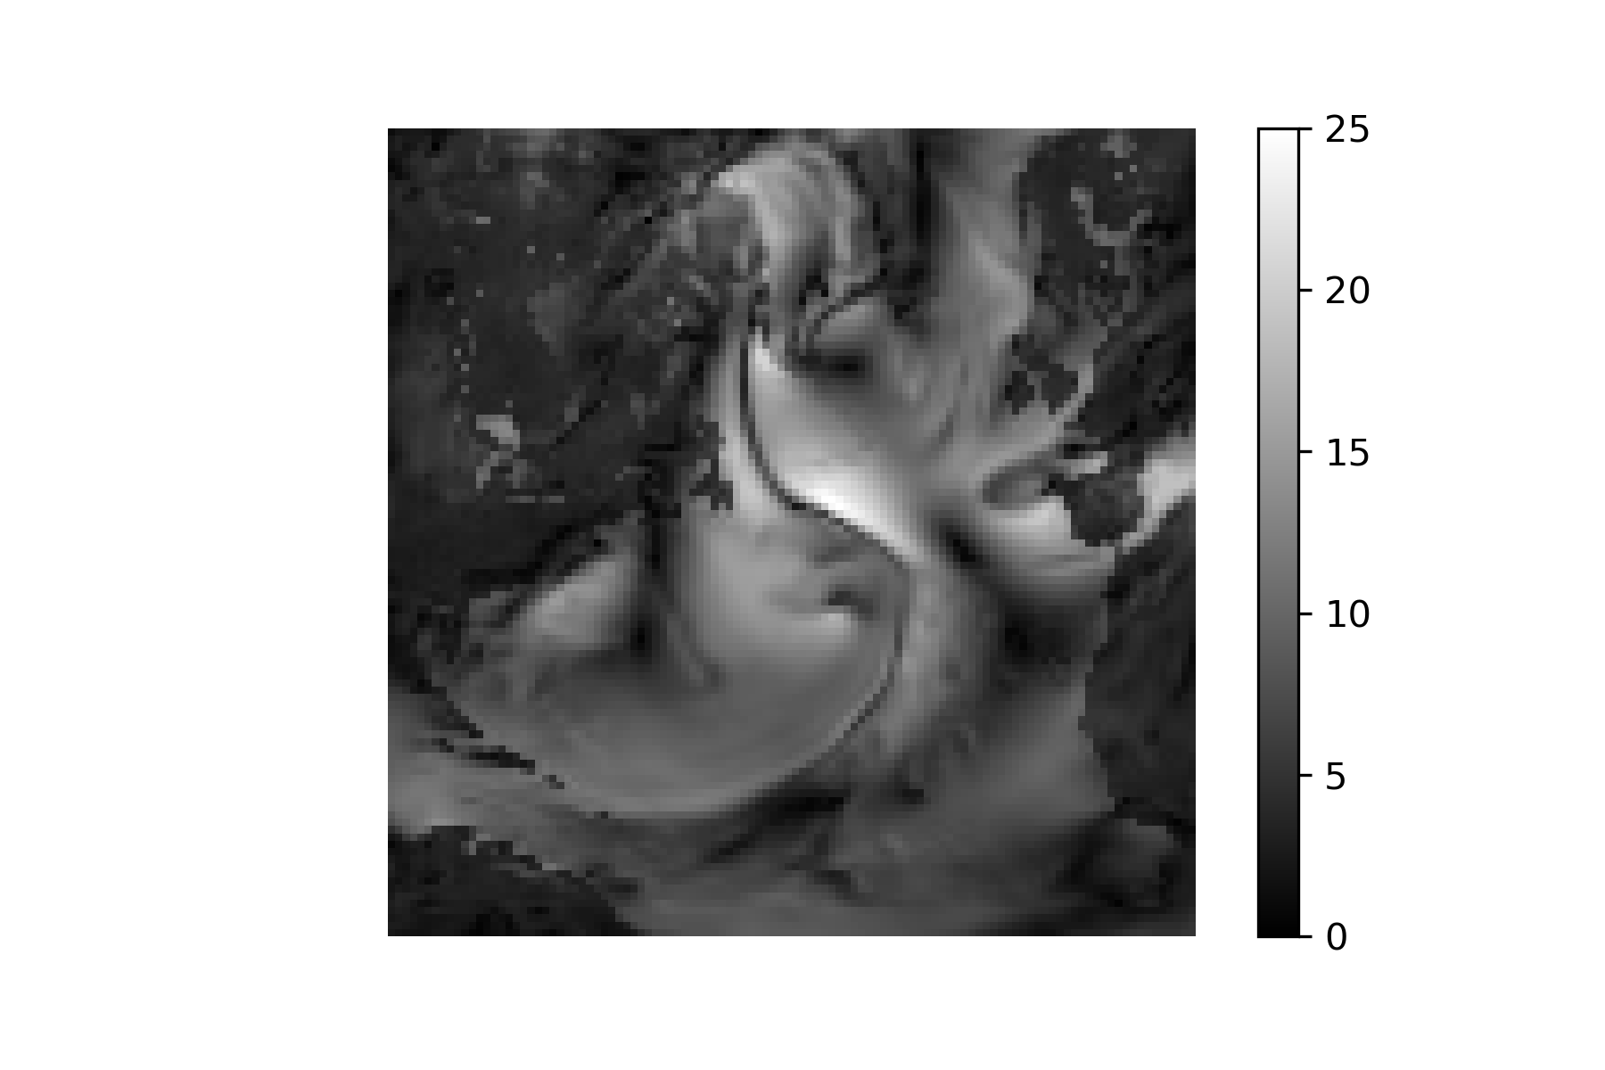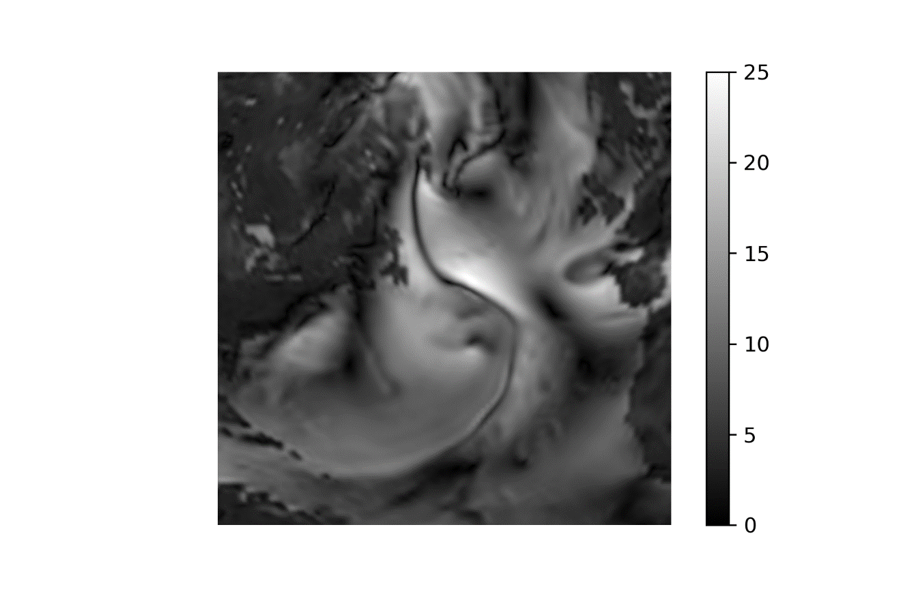

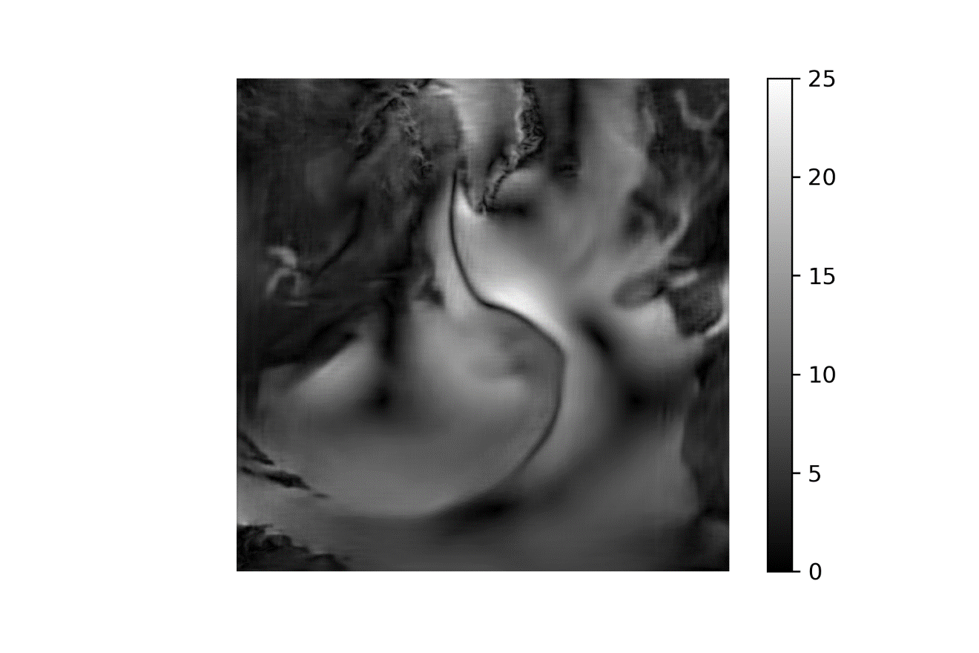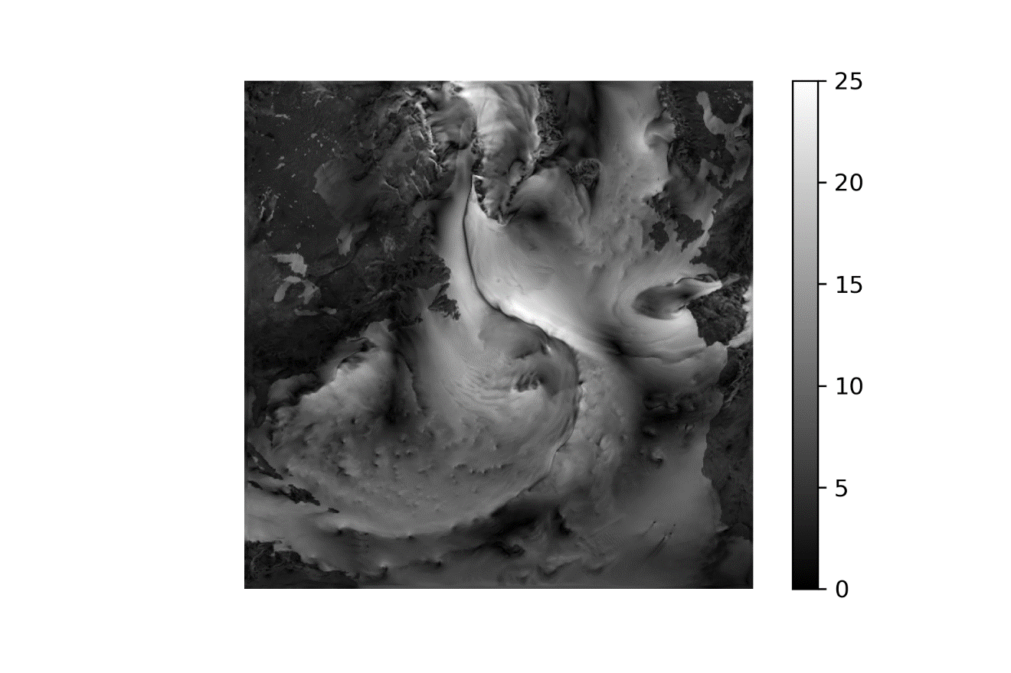

(1 January 2010 Low-Interp-NN-High)

|  |  |  |  |  |  |  |  |  |  |
| --- | --- | --- | --- | --- | --- | --- | --- | --- | --- |
|  | Bicubic interpolation | SRGAN-2 (50 epochs)  train, val | | NN (135 epochs)  train, val | | NN (200 epochs)  train, val | | NN (250 epochs)  train, val | |
| RMSE (wind, m/s) | 1,435 | 1,443 | 1,478 |  |  |  |  |  |  |
| RMSE (SLP, hPa) | 0,576 | 0,785 | 0,785 |  |  |  |  |  |  |
| RMSE-95 (m/s) | 1,898 | 2,237 | 2,351 |  |  |  |  |  |  |
| PSNR | 35,159 | 34,234 | 34,094 |  |  |  |  |  |  |

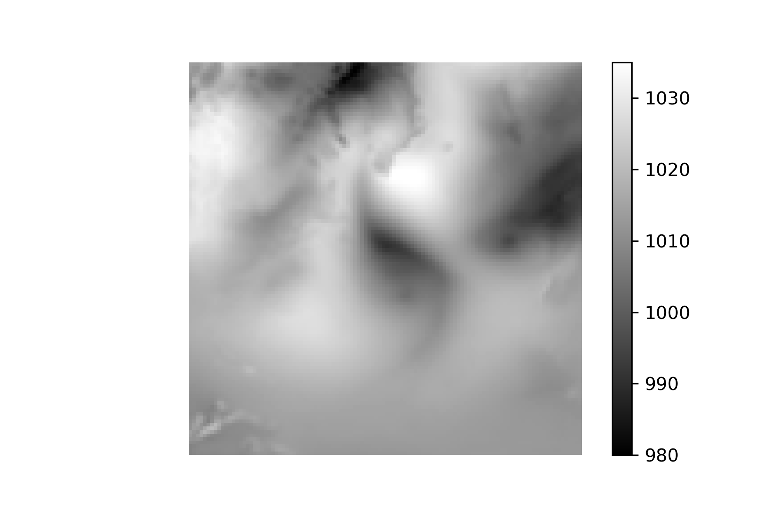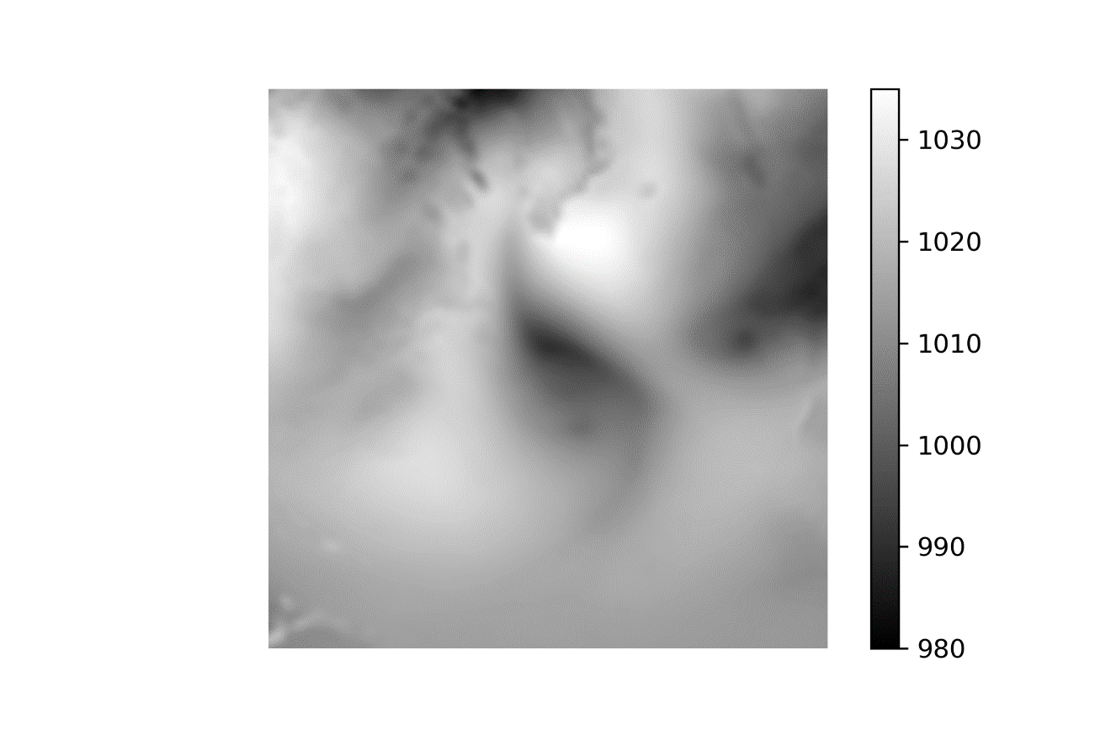

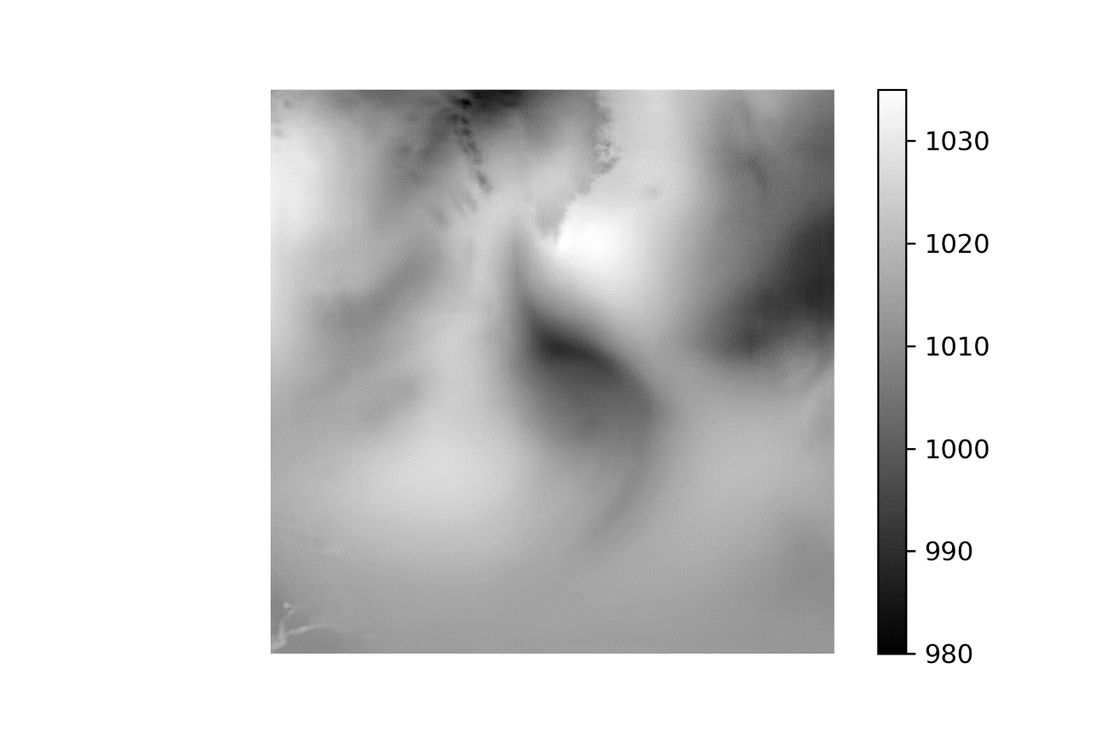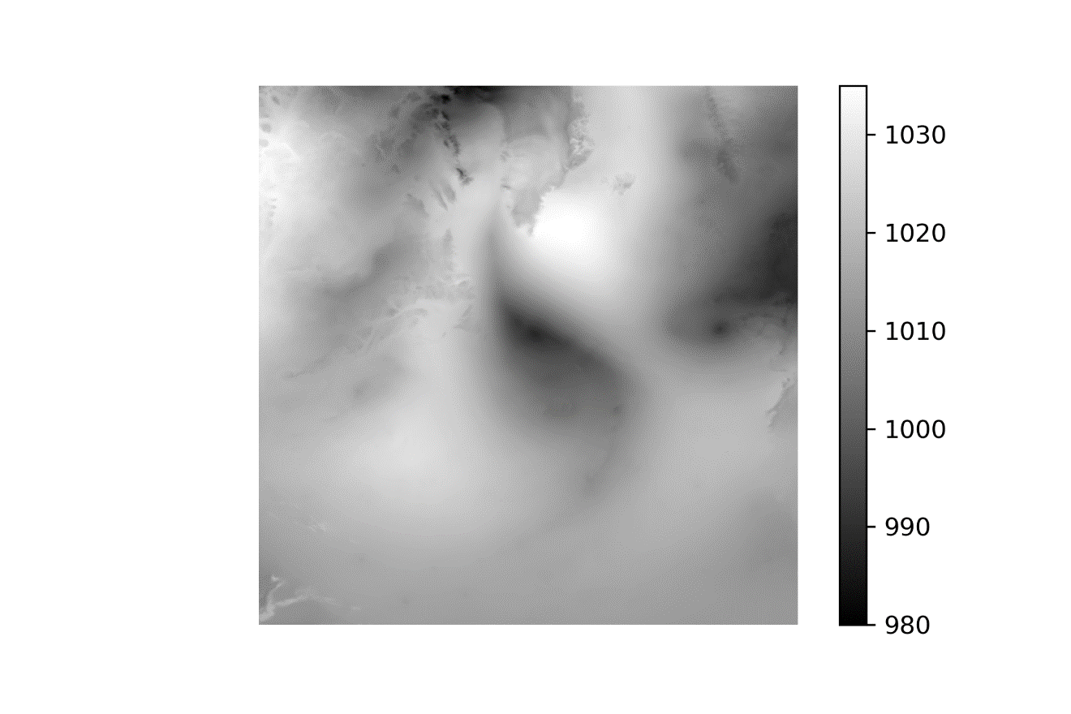

(1 Jul 2010 Low-Interp-NN-High)

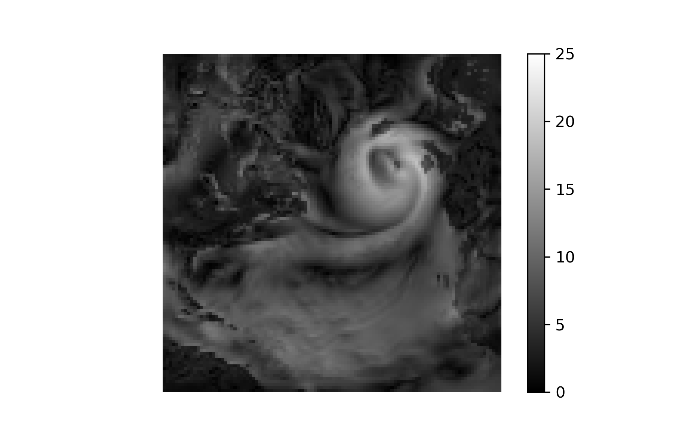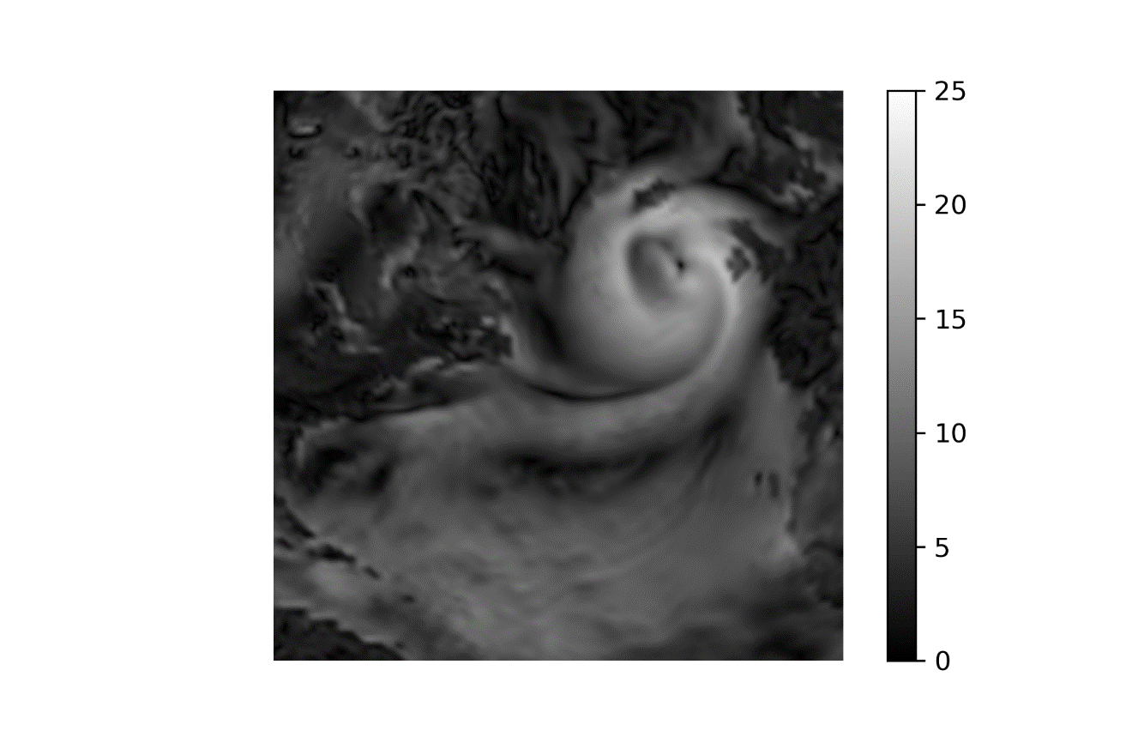

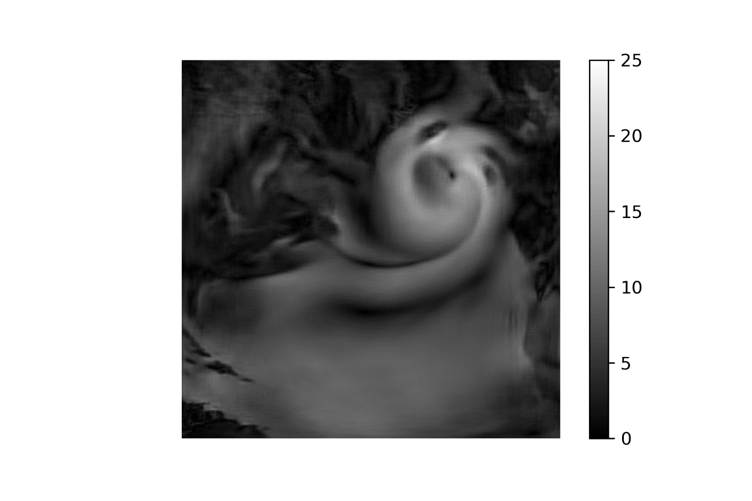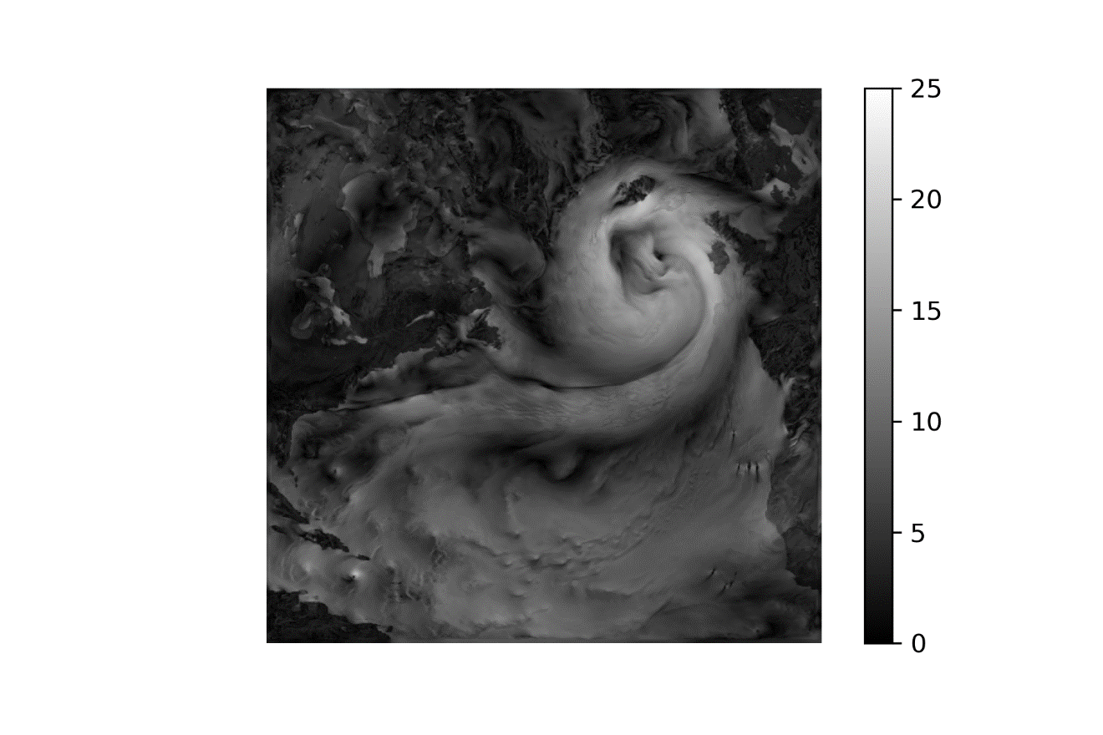

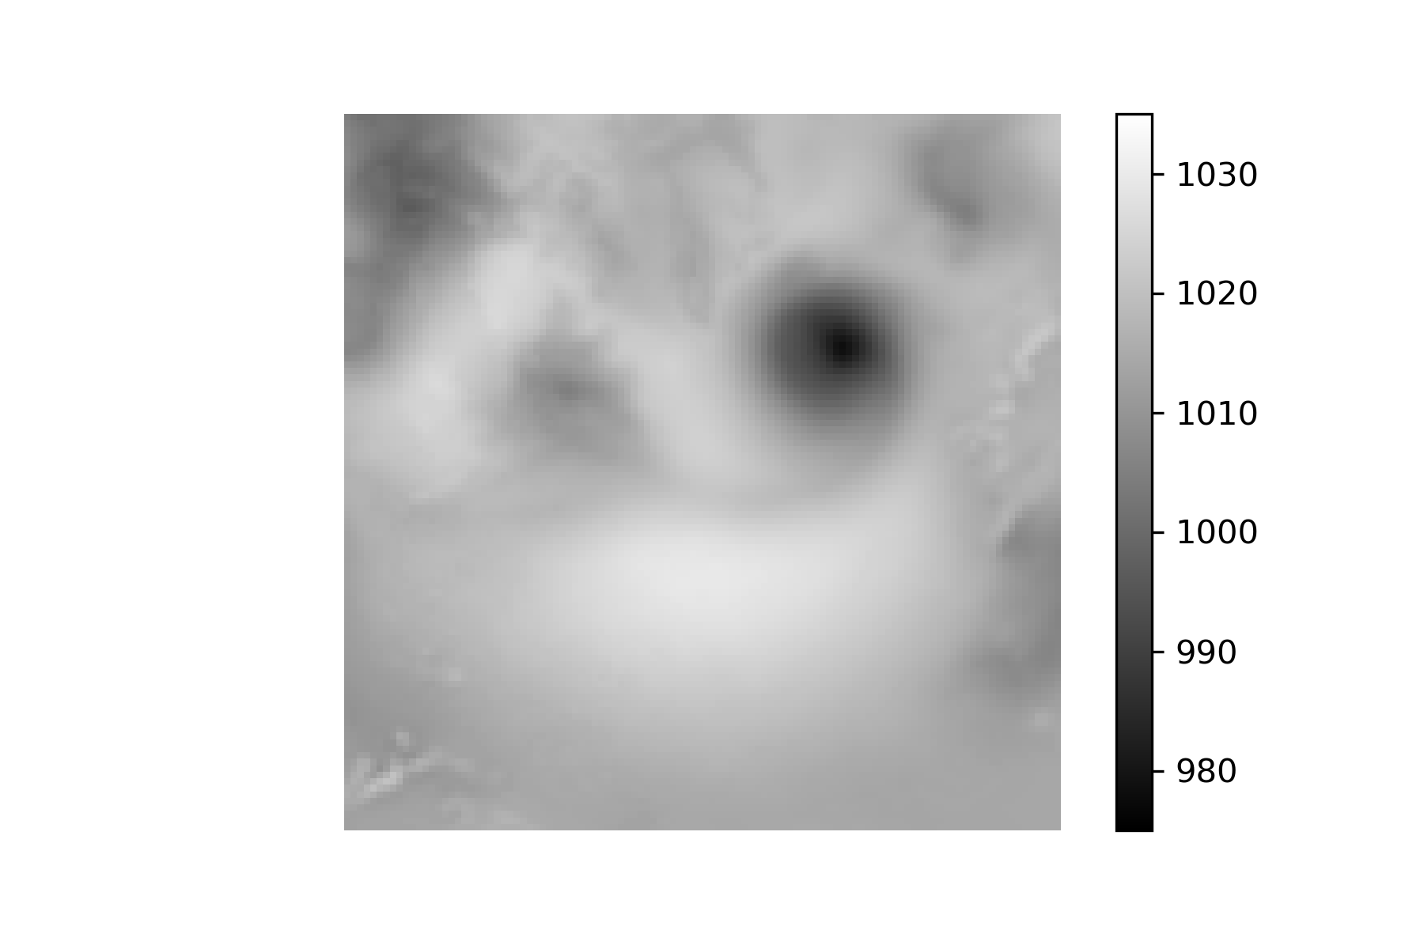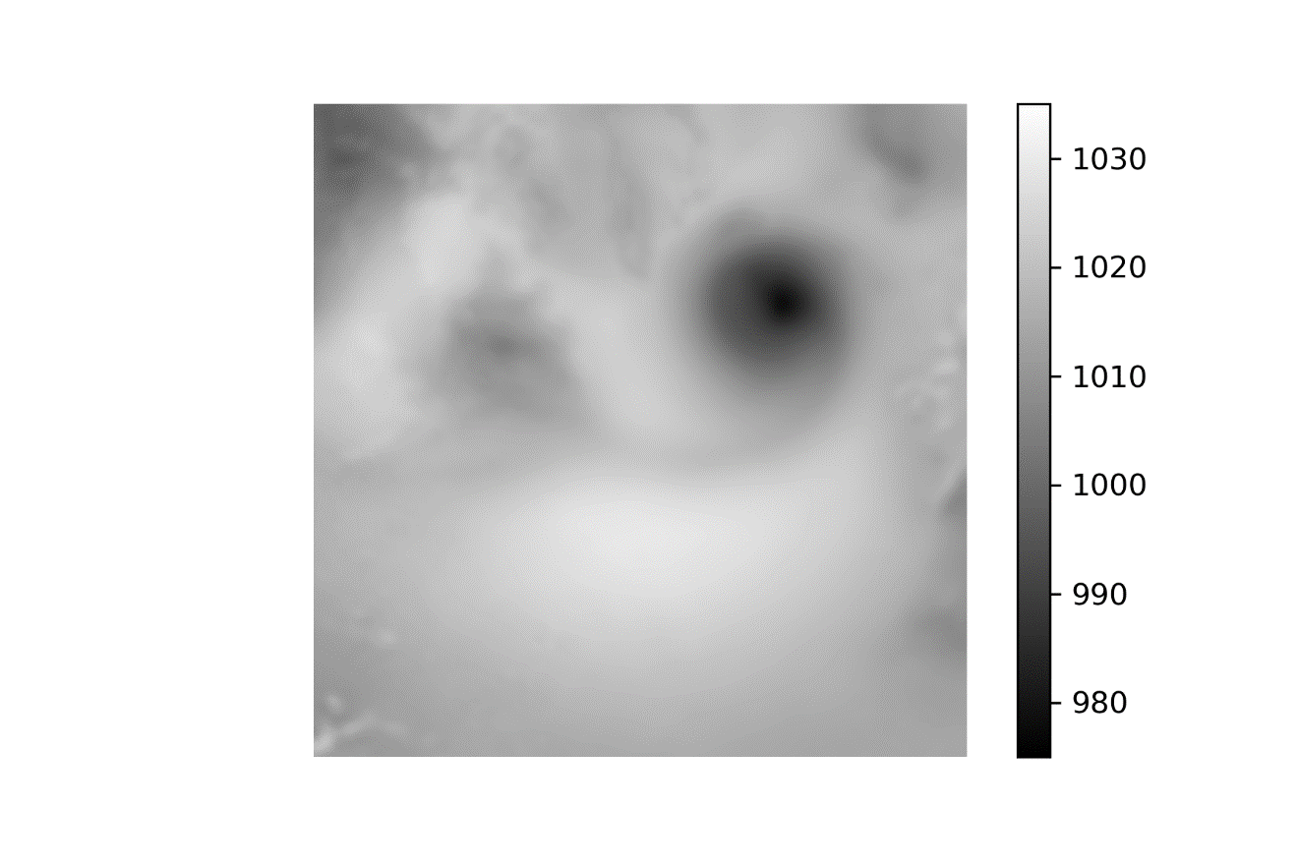

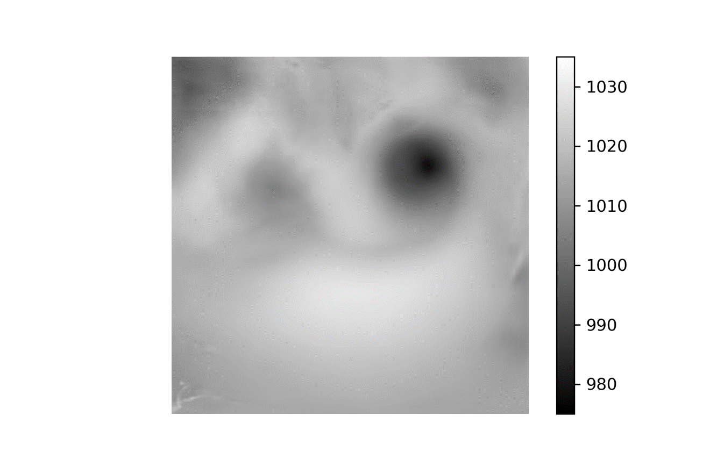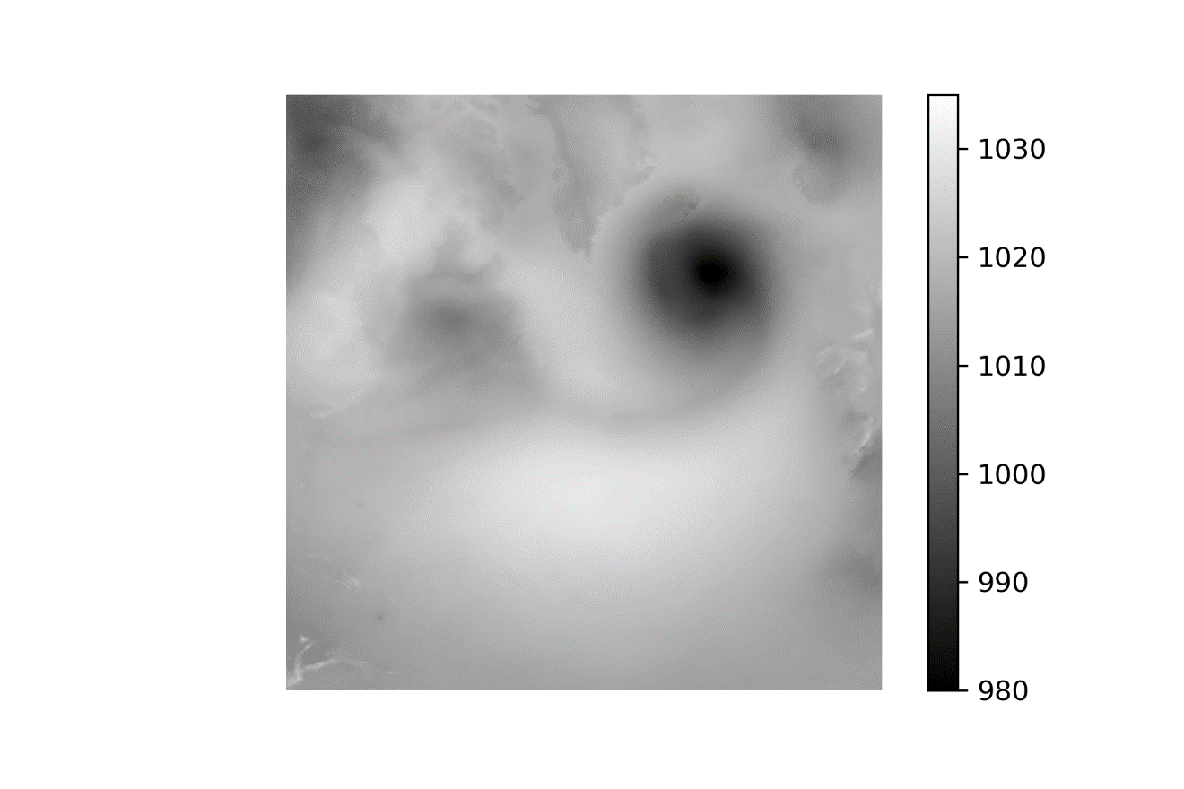

1 Jan 2010 – 50-70-High

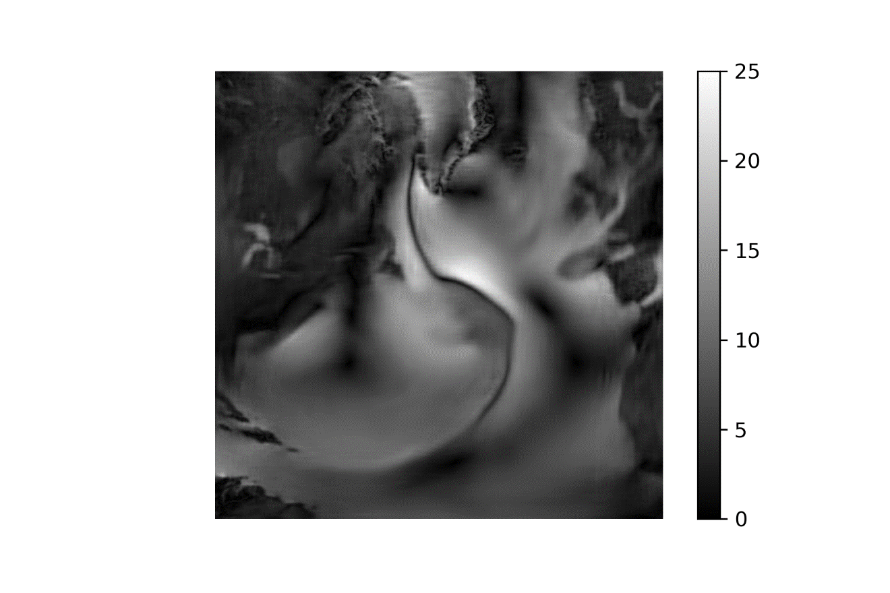

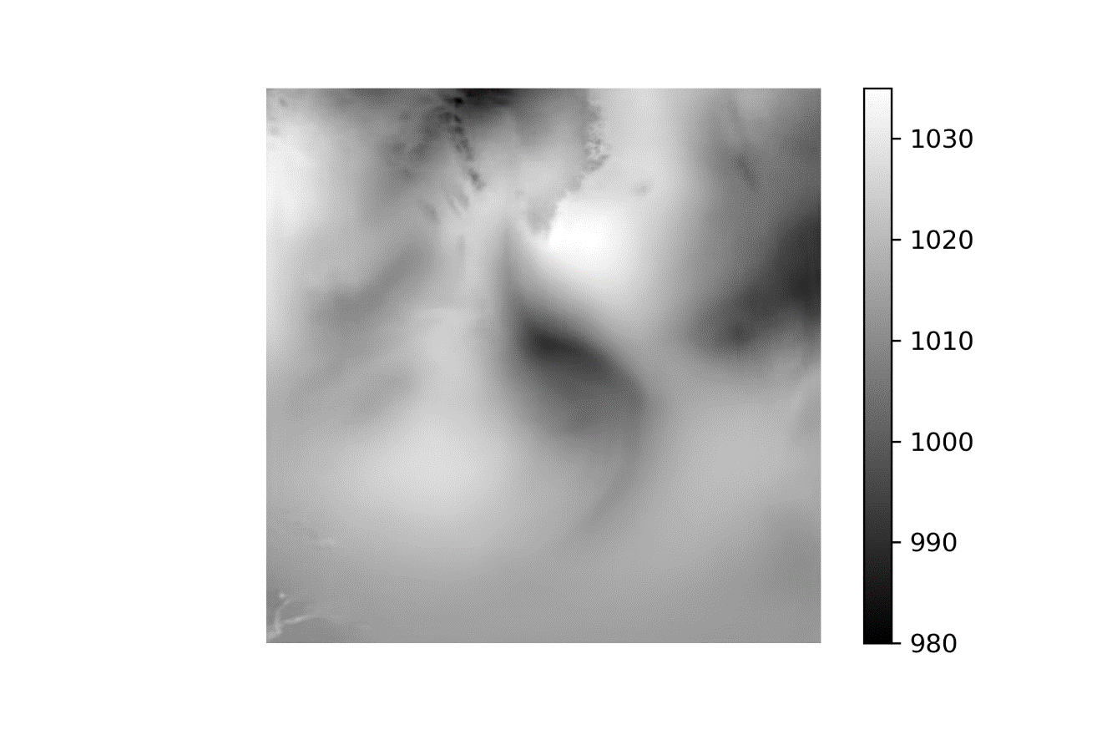

1 Jul 2010 – 50-70-High

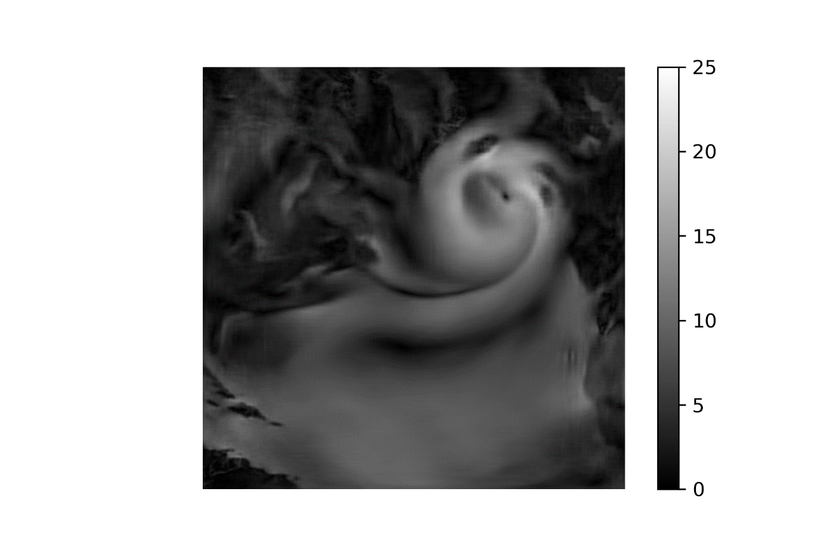

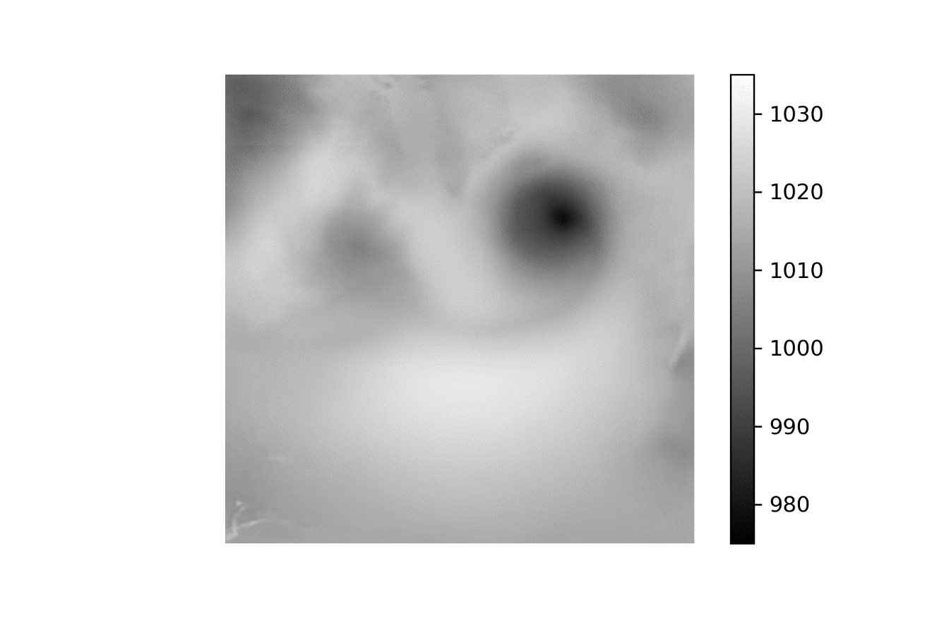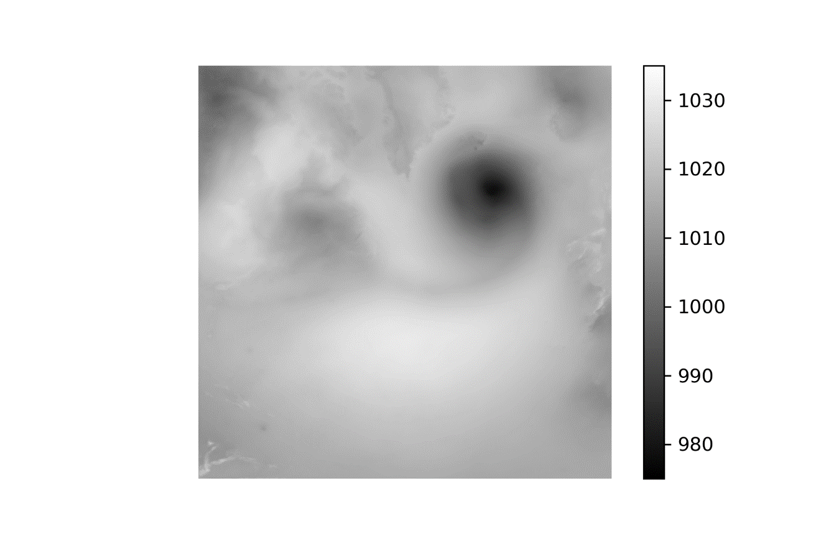

1 Jan 2010 – 50-100-200

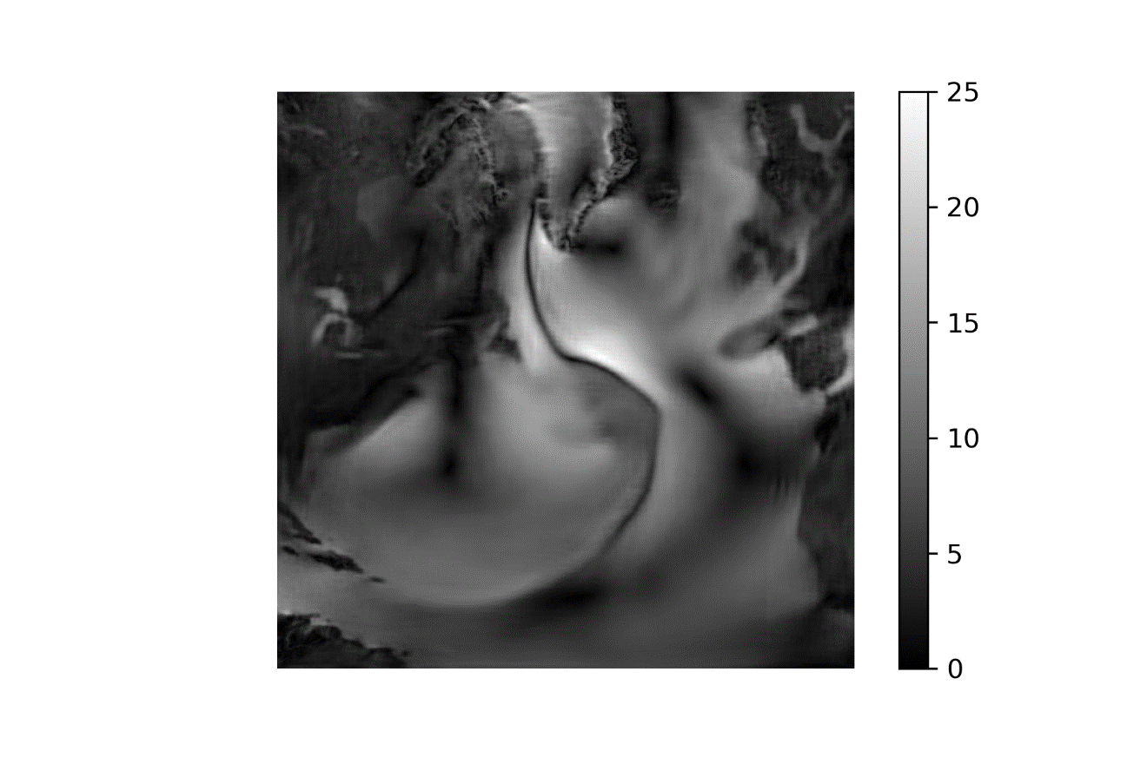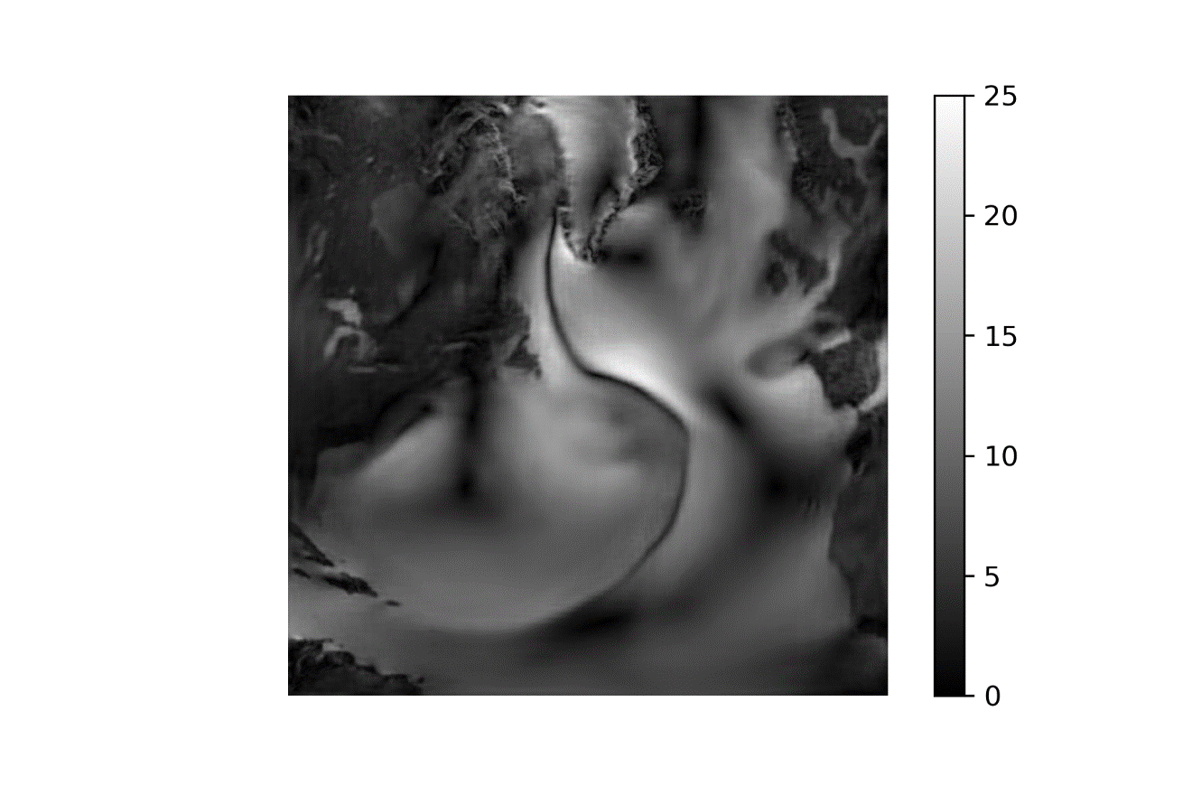

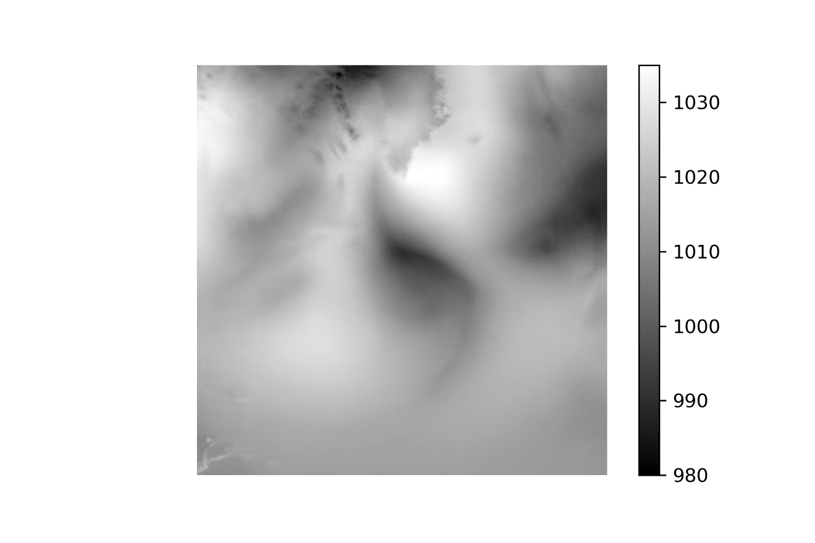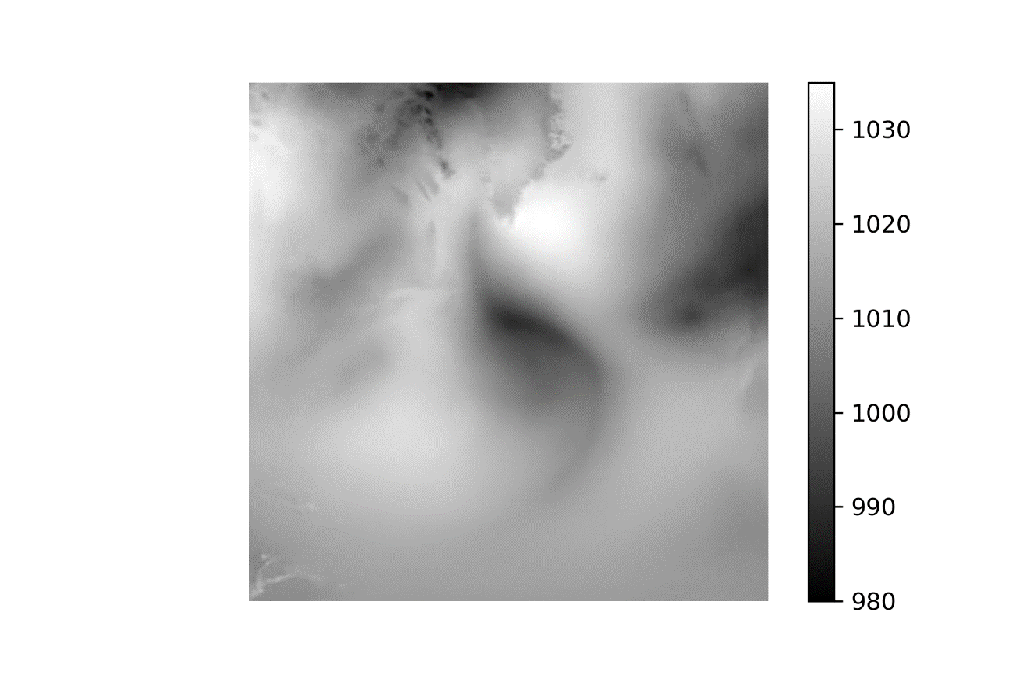

1 Jul 2010 – 50-100-200

